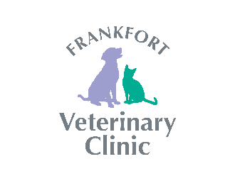
Scott L. Nieves, DVM
715 East Main Street
Frankfort, KY 40601
Phone 502-223-7277

Post-Dental Home Care Instructions

Your animal received a professional dental cleaning under general anesthesia. The teeth and gum line were thoroughly scaled, polished and inspected for signs of dental disease. Any abnormalities found will be discussed with you upon discharge. The dental cleaning is the first step in preventing plaque and tartar build-up that leads to dental disease. The next step is at-home maintenance. By maintaining clean teeth you can help your pet avoid periodontal disease as well as diseases of the kidney, heart and liver. In addition, you can help to prevent oral cavity pain associated with infections of the teeth and gums.

Medications
If teeth were extracted or if your animal has severe dental disease, antibiotics and pain medications may be necessary after your pet’s dental procedure. Give as directed by Frankfort Veterinary Clinic.

Diet
Offer small amounts of your pet’s regular food and water for the next 24 hours, as your pet may still be a little nauseous from anesthesia. If several extractions were done a soft diet may be necessary. You may soften your pet’s food with warm water.

Brushing and Maintenance
- Brush teeth at least 3 times per week with a toothbrush kit. A technician can show you how to properly brush your pet’s teeth. Be sure you pull both cheeks back and brush molars, and most importantly along the gum line where tartar accumulates.

To brush teeth:
- If your pet will not let you brush its teeth, then begin by playing with its mouth and get your pet used to you looking at its teeth and gums. Give praise and treats when your pet cooperates.
- Slowly move finger along gums on outside of upper and lower teeth on both sides.
- Take finger brush or finger covered with a soft cloth or gauze and apply a small amount of tooth paste and then rub along gum line. If your pet objects to toothpaste, you may want to try a new flavor.
- Begin brushing teeth with finger brush or regular soft toothbrush. (Be sure to pull cheeks back and brush molars!)
- Brush teeth at least 3 times per week.

- Rinse mouth with CET oral hygiene rinse daily if brushing is not an option, or in conjunction with brushing as directed during discharge after dental.
- CET chews-A free sample of CET chews are provided at discharge. These chews are lined with an enzyme (similar to the enzymes which are found in toothpaste) which will adhere to teeth while chewing and help prevent tartar build-up. Although a great tool in maintaining your pet’s healthy oral cavity, these chews should not replace regular brushing.

